Cross-quantilogram: AUDUSD and USDCAD
Method 20 / daily log returns / expanding quantiles / Alpari D1 full available history

Study setup
Logical pair: AUDUSD , USDCAD
Broker symbols: AUDUSD_i , USDCAD_i
Snapshot: 2026-11-03_majors_alpari_D1
Timeframe: D1
Matched return window: 1999-01-05 to 2026-11-02 (UTC bar dates)
Matched return count n: 7204
Dropped unfinished last bar dated 2026-11-03 UTC after a tick-volume check against the prior complete day.
Quantiles: expanding window, min history 252 days
tau in [0.05, 0.2]; k=0..10; headline tau=0.05, k=1
Complete matched rows (Excel): AUDUSD-USDCAD_CQ_D1.xlsx
Complete matched rows (HTML table): AUDUSD-USDCAD_CQ_D1_data.html

Method carried forward
The cross-quantilogram rho_tau(k) measures linkage among centered quantile-hit indicators of matched daily log returns of close, ln(close_t / close_t-1). Quotes are not inverted. At each date t, the tau-quantile uses only returns through t (expanding window) after a minimum history of 252 days. Hits are h_t = 1(r_t < q_t) - tau. rho_tau(k) is the normalized cross-product of h_x,t with h_y,t+k. Levels tau in {0.05, 0.20} and lags k=0..10 are pre-specified; headline is tau=0.05, k=1 both directions. Same-sample Pearson r is a side check. This is not causation and not a trading signal.

Results (headline)
rho_AUDUSD->USDCAD(tau=0.05,k=1): 0.061431
rho_USDCAD->AUDUSD(tau=0.05,k=1): 0.033828
rho_AUDUSD->USDCAD(tau=0.20,k=1): 0.040262
rho_USDCAD->AUDUSD(tau=0.20,k=1): 0.014383
Pearson r: -0.647362

CQ table (tau=0.05)
k | rho_AUDUSD_to_USDCAD | n_AUDUSD_to_USDCAD | rho_USDCAD_to_AUDUSD | n_USDCAD_to_AUDUSD
0 | -0.05203788 | 6953 | -0.05203788 | 6953
1 | 0.06143078 | 6952 | 0.03382833 | 6952
2 | 0.05528966 | 6951 | 0.02155308 | 6951
3 | 0.07086344 | 6950 | 0.06755036 | 6950
4 | 0.02479088 | 6949 | 6.901e-05 | 6949
5 | 0.07084917 | 6948 | 0.04606683 | 6948
6 | 0.05855774 | 6947 | 0.02459013 | 6947
7 | 0.05240831 | 6946 | 0.03991805 | 6946
8 | 0.04932991 | 6945 | 0.04297779 | 6945
9 | 0.04932261 | 6944 | 0.01536631 | 6944
10 | 0.04317297 | 6943 | 0.03682881 | 6943

Conclusion
Headline tau=0.05, k=1 for AUDUSD and USDCAD: rho_AUDUSD->USDCAD = 0.0614; rho_USDCAD->AUDUSD = 0.0338. At tau=0.20, k=1: 0.0403 and 0.0144. Same-day tau=0.05 rho(k=0) = -0.0520. Pearson r = -0.6474. This is quantile-hit linkage, not a trading signal.

Charts
Daily closes

Daily log returns

Cross-quantilogram tau=0.05
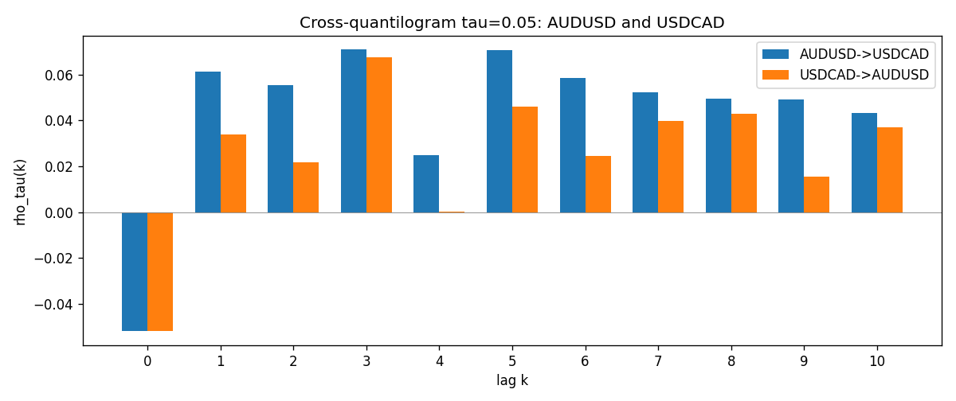

Data report
Matched rows and the CQ sheet are in the sibling Excel workbook named AUDUSD-USDCAD_CQ_D1.xlsx. Embedding all rows as a Word table is impractical; this file holds column summaries and the first and last 15 matched rows.
Columns: time, AUDUSD_open, USDCAD_open, AUDUSD_high, USDCAD_high, AUDUSD_low, USDCAD_low, AUDUSD_close, USDCAD_close, AUDUSD_tick_volume, USDCAD_tick_volume, AUDUSD_spread, USDCAD_spread, AUDUSD_real_volume, USDCAD_real_volume, AUDUSD_log_return, USDCAD_log_return, AUDUSD_h_t005, USDCAD_h_t005
Column summaries (matched calculation rows)
column | count | mean | std | min | 25% | 50% | 75% | max
AUDUSD_open | 7204 | 0.75193151 | 0.13526075 | 0.4785 | 0.6610425 | 0.731405 | 0.8086175 | 1.10284
USDCAD_open | 7204 | 1.2670146 | 0.16899756 | 0.9168 | 1.118975 | 1.298545 | 1.372225 | 1.6183
AUDUSD_high | 7204 | 0.7559812 | 0.13582551 | 0.4878 | 0.6647 | 0.734785 | 0.81467 | 1.10795
USDCAD_high | 7204 | 1.2719163 | 0.16895637 | 0.9336 | 1.123375 | 1.30394 | 1.3767575 | 1.619
AUDUSD_low | 7204 | 0.74787477 | 0.13457623 | 0.4775 | 0.6577 | 0.727495 | 0.8042 | 1.0975
USDCAD_low | 7204 | 1.2624553 | 0.16903522 | 0.9056 | 1.11435 | 1.293585 | 1.3678925 | 1.6102
AUDUSD_close | 7204 | 0.75197934 | 0.13524694 | 0.4786 | 0.6611975 | 0.731695 | 0.808875 | 1.10169
USDCAD_close | 7204 | 1.2670334 | 0.16897258 | 0.916 | 1.11848 | 1.298615 | 1.372515 | 1.6137
AUDUSD_tick_volume | 7204 | 77316.143 | 138115.43 | 109 | 5421.75 | 43310.5 | 71296.75 | 1234623
USDCAD_tick_volume | 7204 | 80846.476 | 147183.52 | 56 | 5511.25 | 40857 | 71531.75 | 1410818
AUDUSD_spread | 7204 | 30.823709 | 16.885829 | 0 | 13 | 30 | 50 | 50
USDCAD_spread | 7204 | 23.505275 | 18.28107 | 0 | 9 | 17 | 40 | 60
AUDUSD_real_volume | 7204 | 5.2399076e+09 | 1.2535442e+11 | 0 | 0 | 0 | 0 | 3.811512e+12
USDCAD_real_volume | 7204 | 1.8332738e+10 | 9.6584767e+10 | 0 | 0 | 0 | 0 | 2.5751613e+12
AUDUSD_log_return | 7204 | 2.007e-05 | 0.0075444 | -0.08602525 | -0.00386183 | 0.00027895 | 0.00414528 | 0.0806166
USDCAD_log_return | 7204 | -1.21e-05 | 0.00514438 | -0.03859748 | -0.00283637 | 4.97e-05 | 0.00272781 | 0.03436319
AUDUSD_h_t005 | 6953 | -0.00340141 | 0.21079268 | -0.05 | -0.05 | -0.05 | -0.05 | 0.95
USDCAD_h_t005 | 6953 | 0.00220768 | 0.22246158 | -0.05 | -0.05 | -0.05 | -0.05 | 0.95
First 15 matched rows (selected columns)
time | AUDUSD_log_return | USDCAD_log_return | AUDUSD_h_t005 | USDCAD_h_t005
1999-01-05 | -0.00080418179 | -0.010131666 | nan | nan
1999-01-06 | 0.011836351 | -0.0003306769 | nan | nan
1999-01-07 | 0.0088650256 | 0.0015202092 | nan | nan
1999-01-08 | 0.00031515916 | -0.0020495197 | nan | nan
1999-01-11 | 0.0072213815 | -0.0035137769 | nan | nan
1999-01-12 | -0.0048608485 | 0.0066194721 | nan | nan
1999-01-13 | -0.0078902098 | 0.0045420214 | nan | nan
1999-01-14 | -0.002696916 | 0.0069376546 | nan | nan
1999-01-15 | 0.007123101 | -0.0056905671 | nan | nan
1999-01-18 | 0.00094592471 | 0.00098344542 | nan | nan
1999-01-19 | 0.0072225153 | 0.002748513 | nan | nan
1999-01-20 | 0.0012507819 | -0.0059646885 | nan | nan
1999-01-21 | 0.00078094498 | -0.0042823796 | nan | nan
1999-01-22 | -0.012252745 | 0.0025057712 | nan | nan
1999-01-25 | -0.0039591468 | 0.00085579808 | nan | nan
Last 15 matched rows (selected columns)
time | AUDUSD_log_return | USDCAD_log_return | AUDUSD_h_t005 | USDCAD_h_t005
2026-10-13 | 0.0035007712 | -0.0046395653 | -0.05 | -0.05
2026-10-14 | -0.0015193215 | 0.0015184751 | -0.05 | -0.05
2026-10-15 | -0.0075447063 | -0.0036101503 | -0.05 | -0.05
2026-10-16 | 0.0033906408 | -0.0034322068 | -0.05 | -0.05
2026-10-19 | 0.0050859986 | -0.0018835331 | -0.05 | -0.05
2026-10-20 | 0.0034620426 | -0.0037066008 | -0.05 | -0.05
2026-10-21 | 0.0036066384 | -0.00084691787 | -0.05 | -0.05
2026-10-22 | -0.0012672558 | -0.0026307268 | -0.05 | -0.05
2026-10-23 | 0.0023765656 | 2.85545e-05 | -0.05 | -0.05
2026-10-26 | -0.0032032829 | 5.7106554e-05 | -0.05 | -0.05
2026-10-27 | 0.0016669876 | 0.0025379458 | -0.05 | -0.05
2026-10-28 | 0.0040915541 | -0.0038379274 | -0.05 | -0.05
2026-10-29 | -0.0040915541 | -0.00011436495 | -0.05 | -0.05
2026-10-30 | 0.0010102376 | -0.0010298736 | -0.05 | -0.05
2026-11-02 | -0.0049184984 | 0.00061519094 | -0.05 | -0.05

